RDS Task

1.Craete MariaDB DB on EC2.
TITLE:
MariaDB on EC2

PREREQUISITES:
EC2 Instance

OBJECTIVE:
To install MariaDB server on an EC2 instance and create a database for application use.

STEP-BY-STEP-IMPLIMENTATION:
Launch an instance and install mariadb using mariadb105-server -y
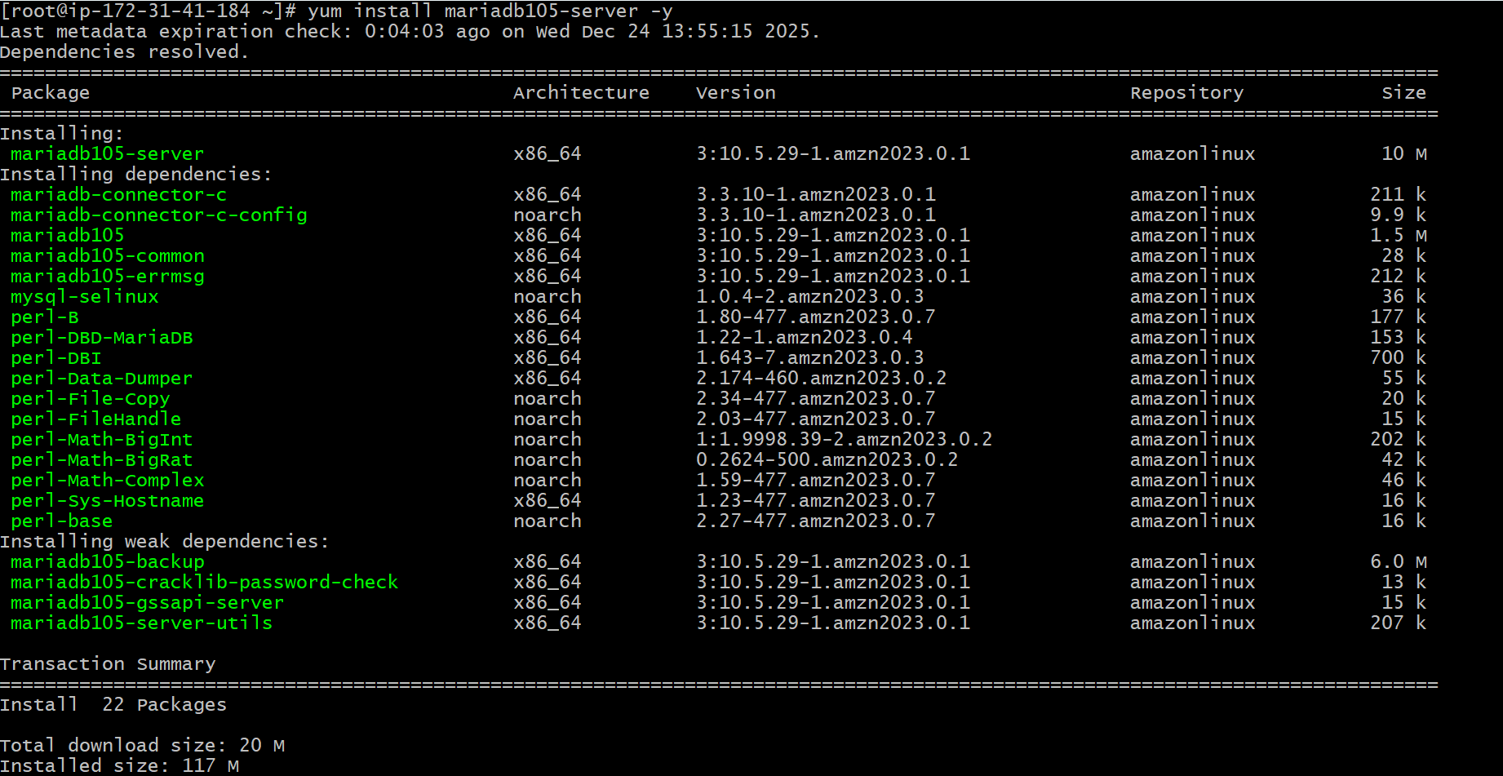
Start with systemctl start mariadb
Enable with systemctl enable mariadb
Status with systemctl status mariadb
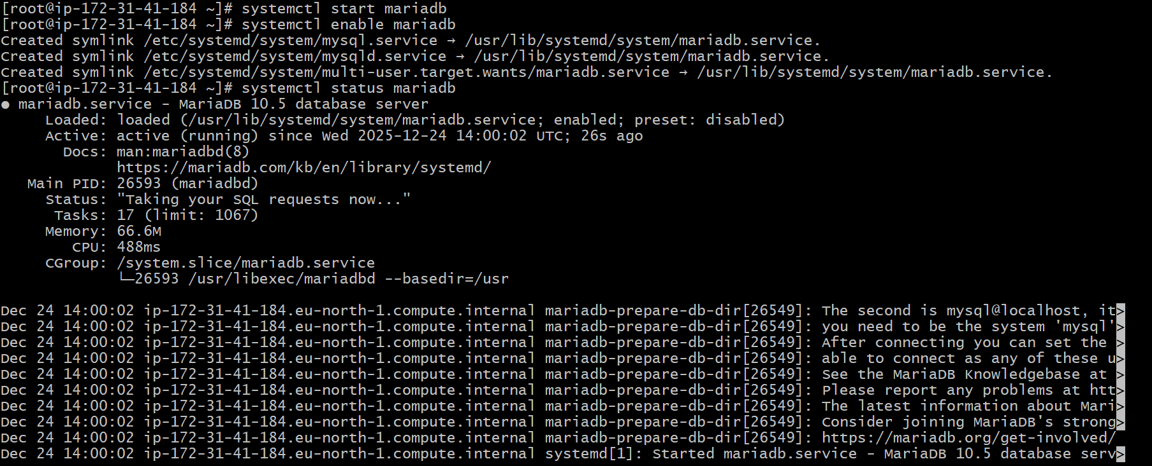
Enter the credentials and create DB
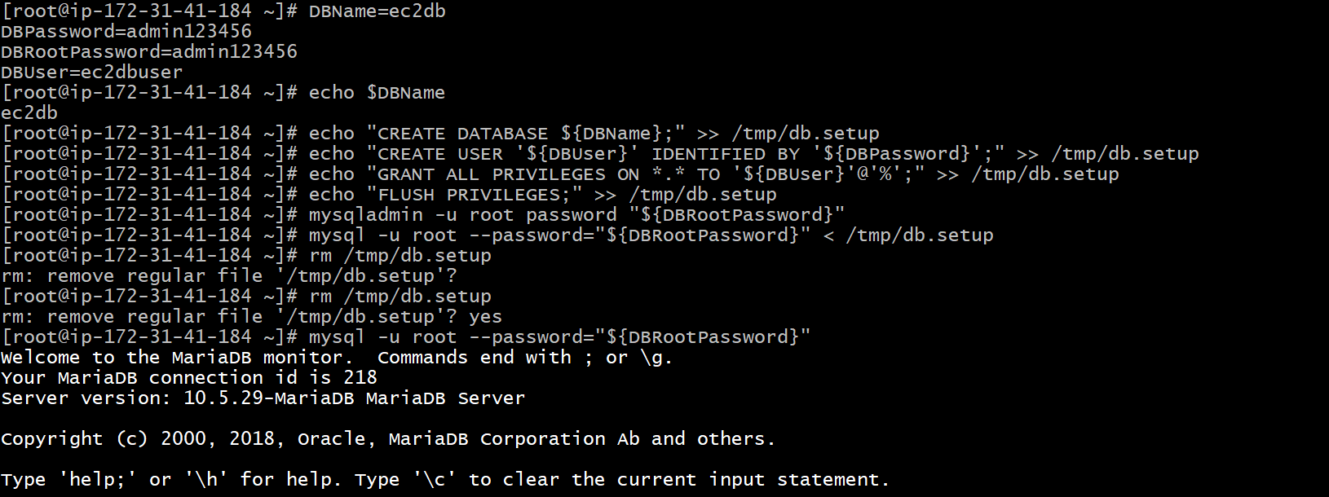

CONCLUSION:
MariaDB is successfully installed on EC2, a database is created, and the server is ready for connections and application integration.

2.Insert some dummy data
TITLE:
Data inserting

PREREQUISITES:
Mariadb
Database
EC2 Instance

OBJECTIVE:
To insert sample dummy rows into an existing MariaDB table

STEP-BY-STEP-IMPLIMENTATION:
Inserted some data inside ec2db
To see the data inserted SELECT * FROM table;

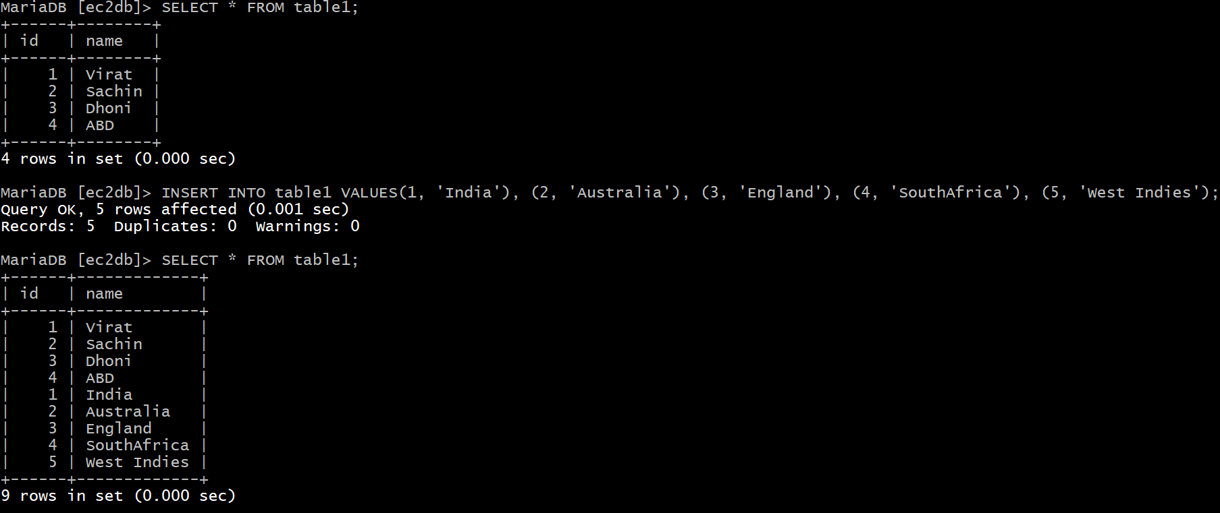

CONCLUSION:
Dummy data is successfully inserted into the table and ready for testing or development use

3. Take the backup of dummy data of EC2.

TITLE:
Backup of data
PREREQUISITES:
Ec2
Mariadb
Mysqldump

OBJECTIVE:
To export and back up dummy data/database from the EC2 instance using mysqldump.

STEP-BY-STEP-IMPLIMENTATION:

Here the command mysqldump -u root -p ec2db > ec2db_backup.sql.
This command will read the database and writes SQL commands and saves them into a file.
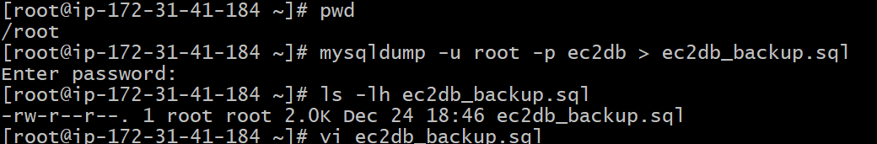
Backup is stored in as ec2db_backup.sql
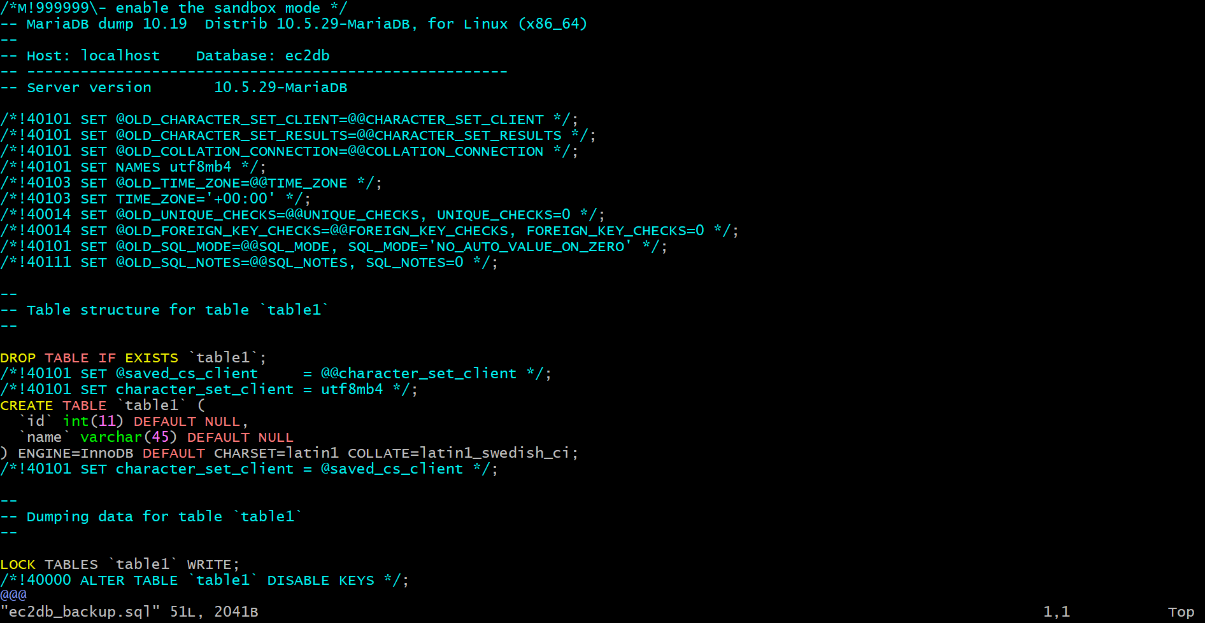
CONCLUSION:
Database backup is successfully taken from EC2 and stored as a dump file for future restoration.

4.Launch MariaDB RDS instance.

TITLE:
RDS Instance

OBJECTIVE:
To launch a MariaDB RDS instance for managed database service in AWS.

PREREQUISITES:
RDS
VPC
Subnets

STEP-BY-STEP-IMPLIMENTATAION:
Go to console and search RDS create instance.

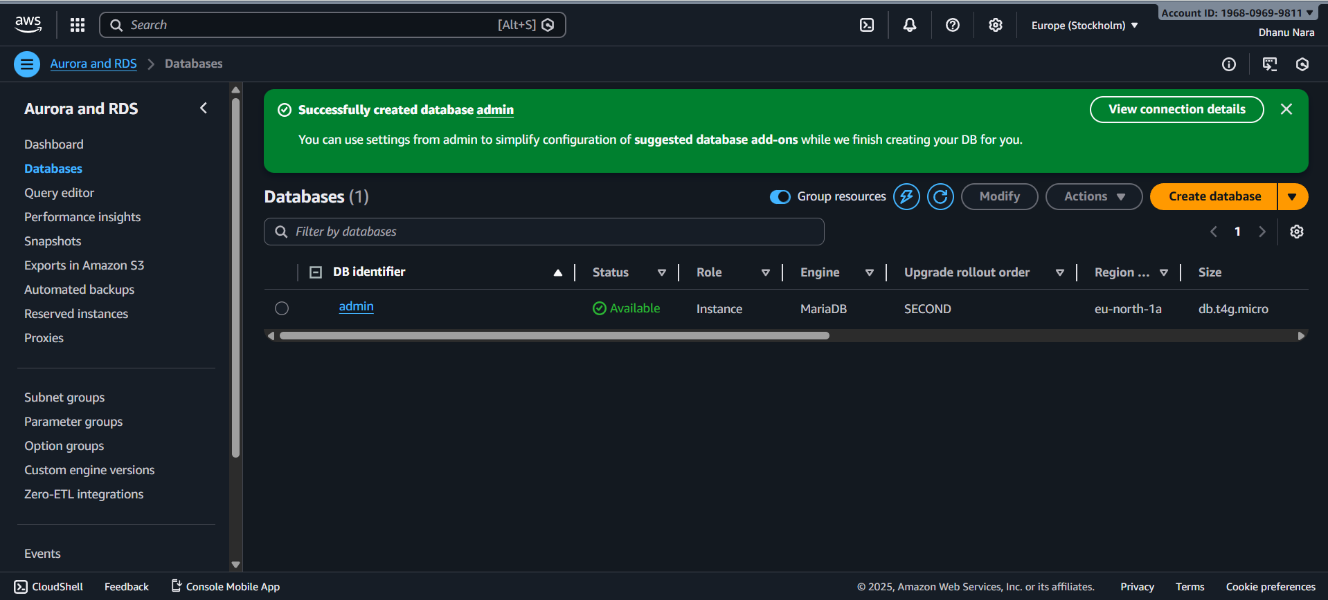
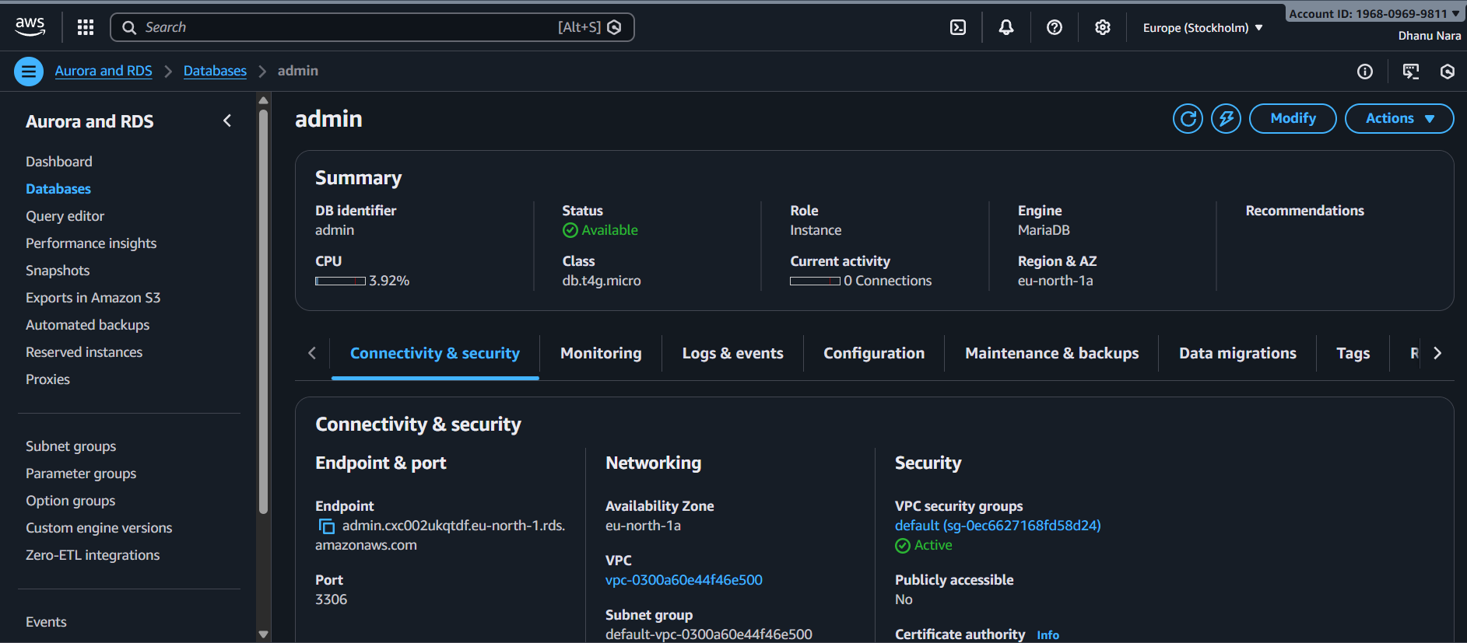
Check the RDS in cli using instance cname
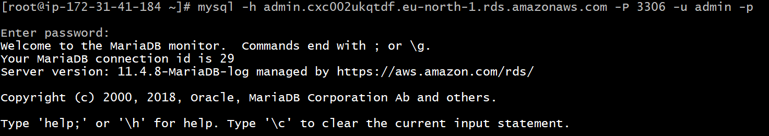

CONCLUSION:
MariaDB RDS instance is successfully created and ready for application use.

5.Migrate database from EC2 to RDS
TITLE:
Database from EC2-RDS

OBJECTIVE:
To export the existing EC2 database and import it into a newly created RDS MySQL/MariaDB instance.

PREREQUISITES:
EC2
RDS
MariaDB
Dump
STEP-BY-STEP-IMPLIMENTATION:
First created a MariaDB and inserted some data inside it.

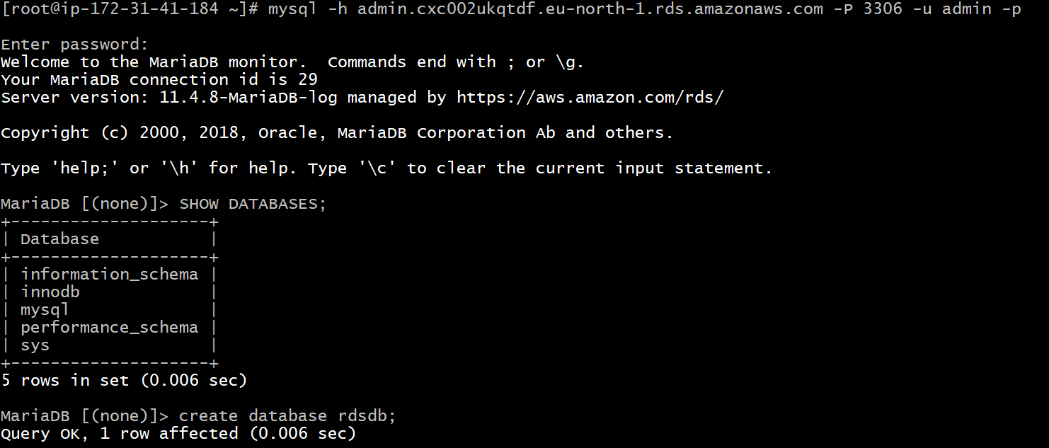
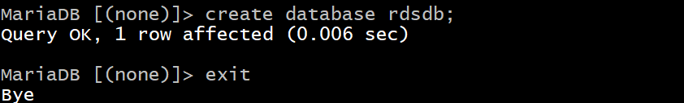
And logged in to RDS and transferred the data
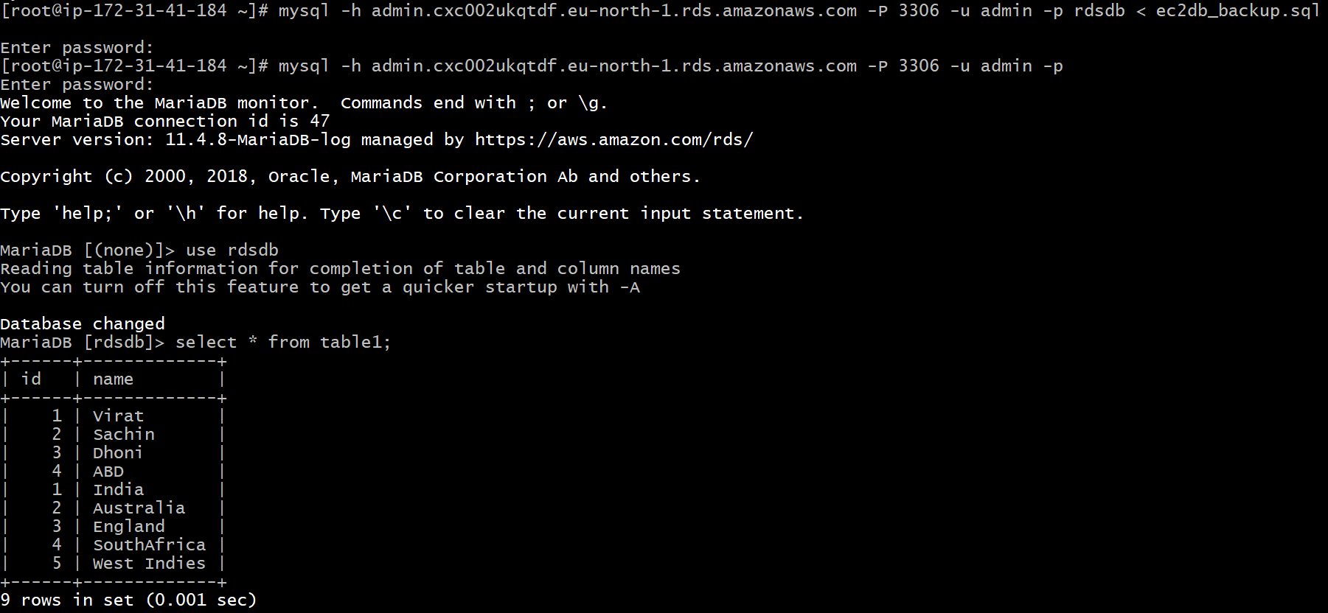

CONCLUSION:
Database is successfully exported from EC2 and imported into RDS, making the data accessible from a managed database service with better reliability and scalability.

6.Install MySQL DB on EC2.

TITLE:
MySQL DB

OBJECTIVE:
To login to MySQL/MariaDB on EC2 and create database, table, and insert dummy records

PREREQUISITES:
EC2
MariaDB

STEP-BY-STEP-IMPLIMENTATION:
Installed MySQL using the script.

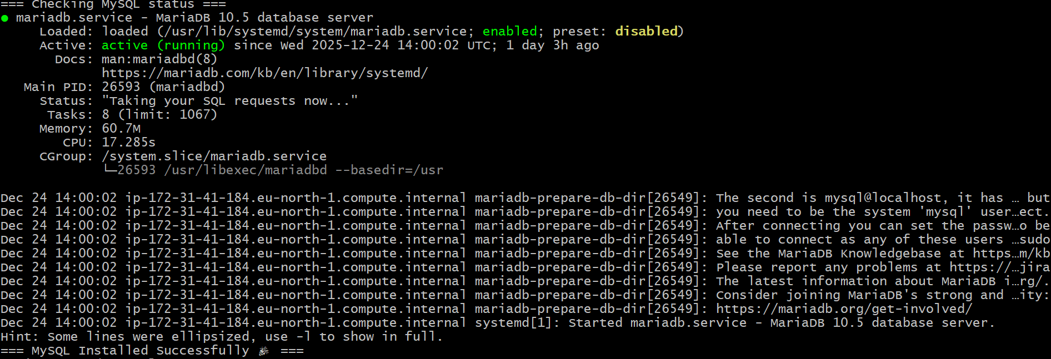
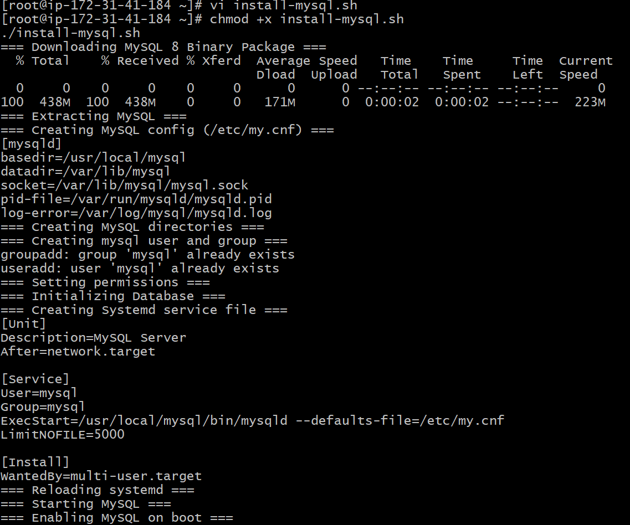
Logged in to MySQL through mysql -u root and inserted some data.
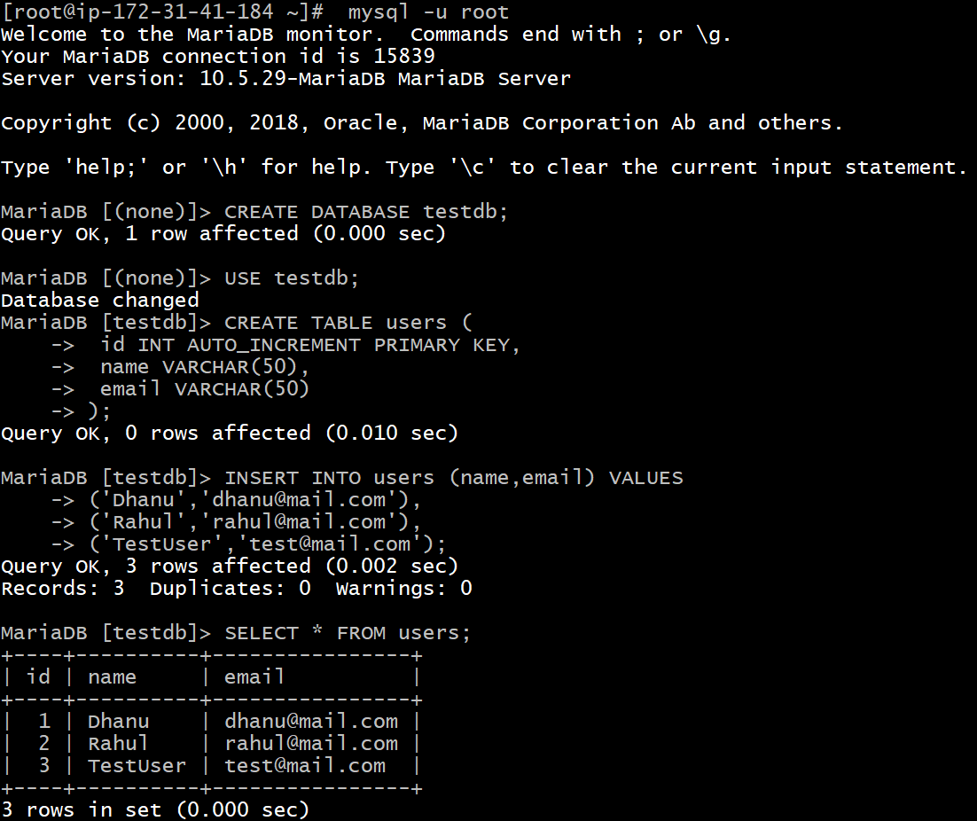

CONCLUSION:
Successfully logged into MySQL/MariaDB on EC2, created a database, table, and inserted test data.

7.Launch MySQL RDS image.
TITLE:
MySQL RDS image

OBJECTIVE:
To connect to the MySQL RDS database from an EC2 instance using the RDS endpoint and MySQL client.
PREREQUISITES:
EC2
RDS
MySQL Image
Endpoint

STEP-BY-STEP-IMPLIMENTATION:
Created a database using MySQL engine type.

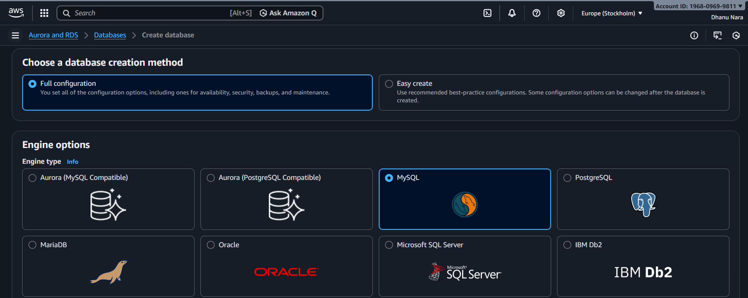
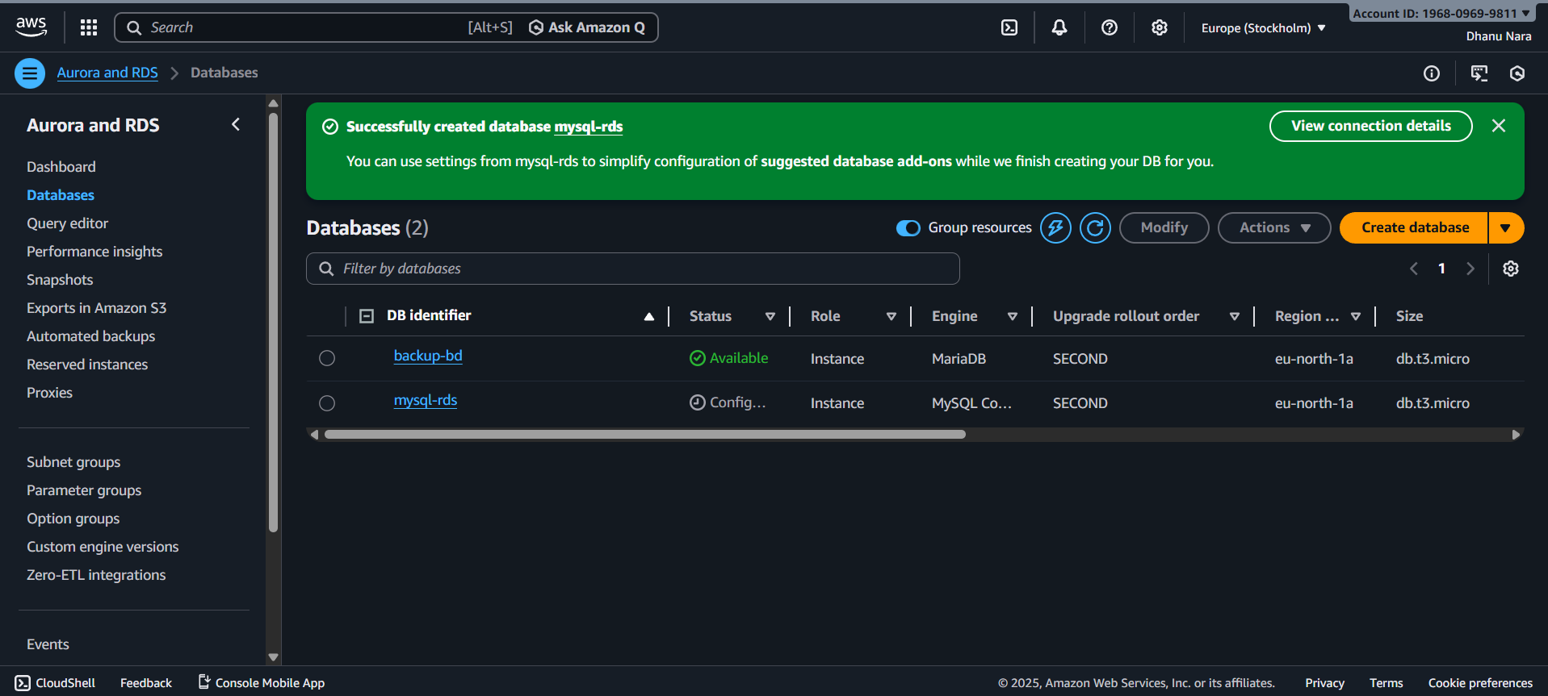
Now logged in to MySQL image using RDS endpoint.
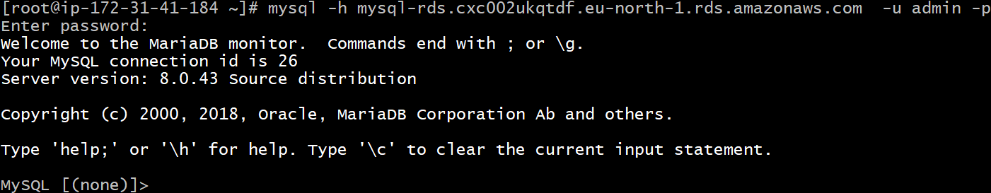

CONCLUSION:
MySQL RDS was successfully accessed from EC2 by configuring Security Groups, using the RDS endpoint, and logging in via the MySQL client.

8.Configure Multi-AZ.

TITLE:
Multi-AZ

OBJECTIVE:
To enable Multi-AZ deployment for RDS to provide high availability and automatic failover by maintaining a standby replica in another Availability Zone.

PREREQUISITES:
RDS
Multi-AZ
Subnets
VPC
Backup

STEP-BY=STEP-IMPLIMENTATION:
First select the database which is created and click on actions and select to convert to Multi-AZ deployment.

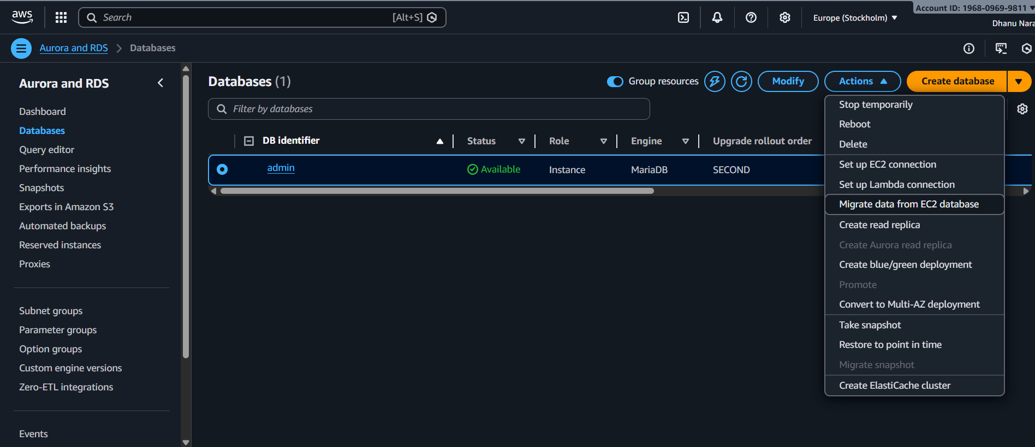
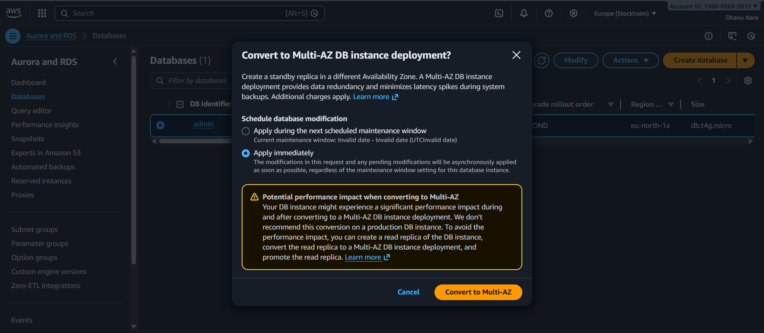
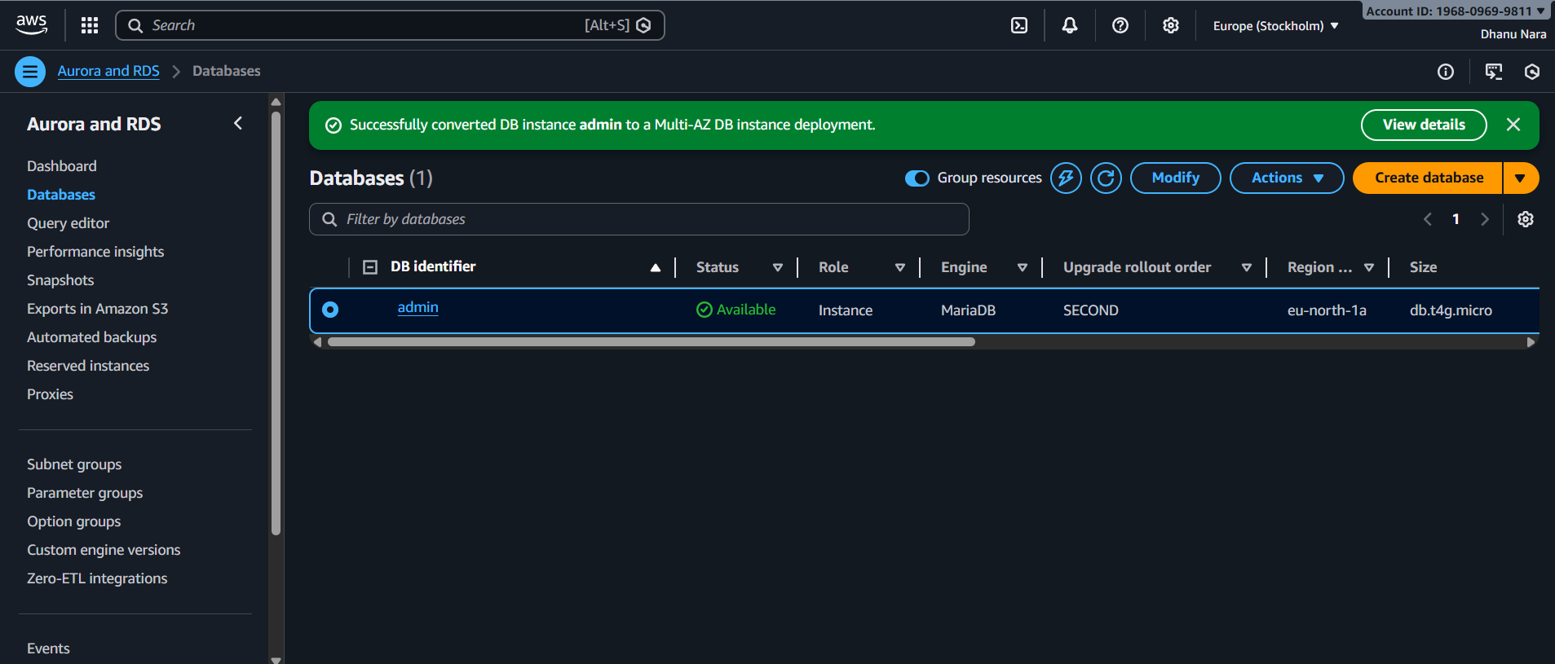

CONCLUSION:
Multi-AZ is successfully enabled, creating a synchronous standby instance in another AZ for automatic failover and high availability.

9.Take backup of DB and restore the DB.

TITLE:
Restore the DB

OBJECTIVE:
To create a backup of a database and restore it into a new or existing MySQL/RDS instance.

PREREQUISITES:
RDS/EC2
MySQL
Dump
Snapshot

STEP-BY-STEP-IMPLIMENTATION:
Here first deleted the database after taking the snapshot of that.

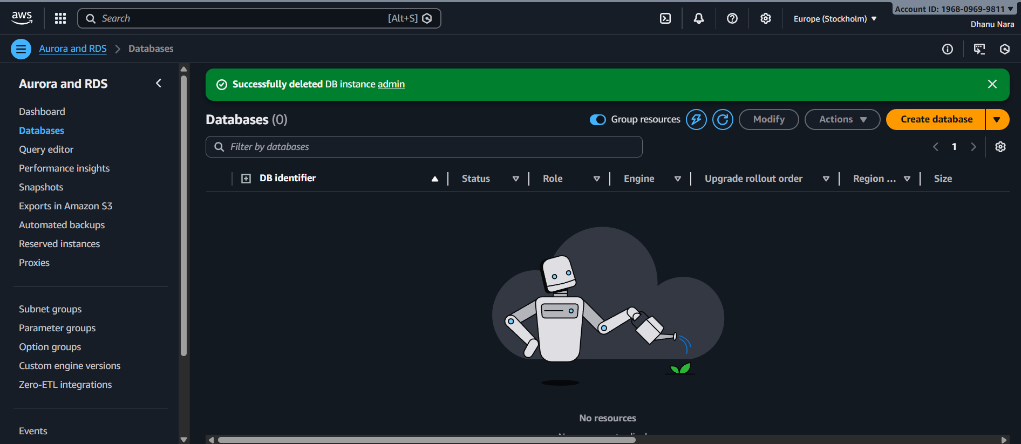
And after going to snapshot select the Restore DB instance.
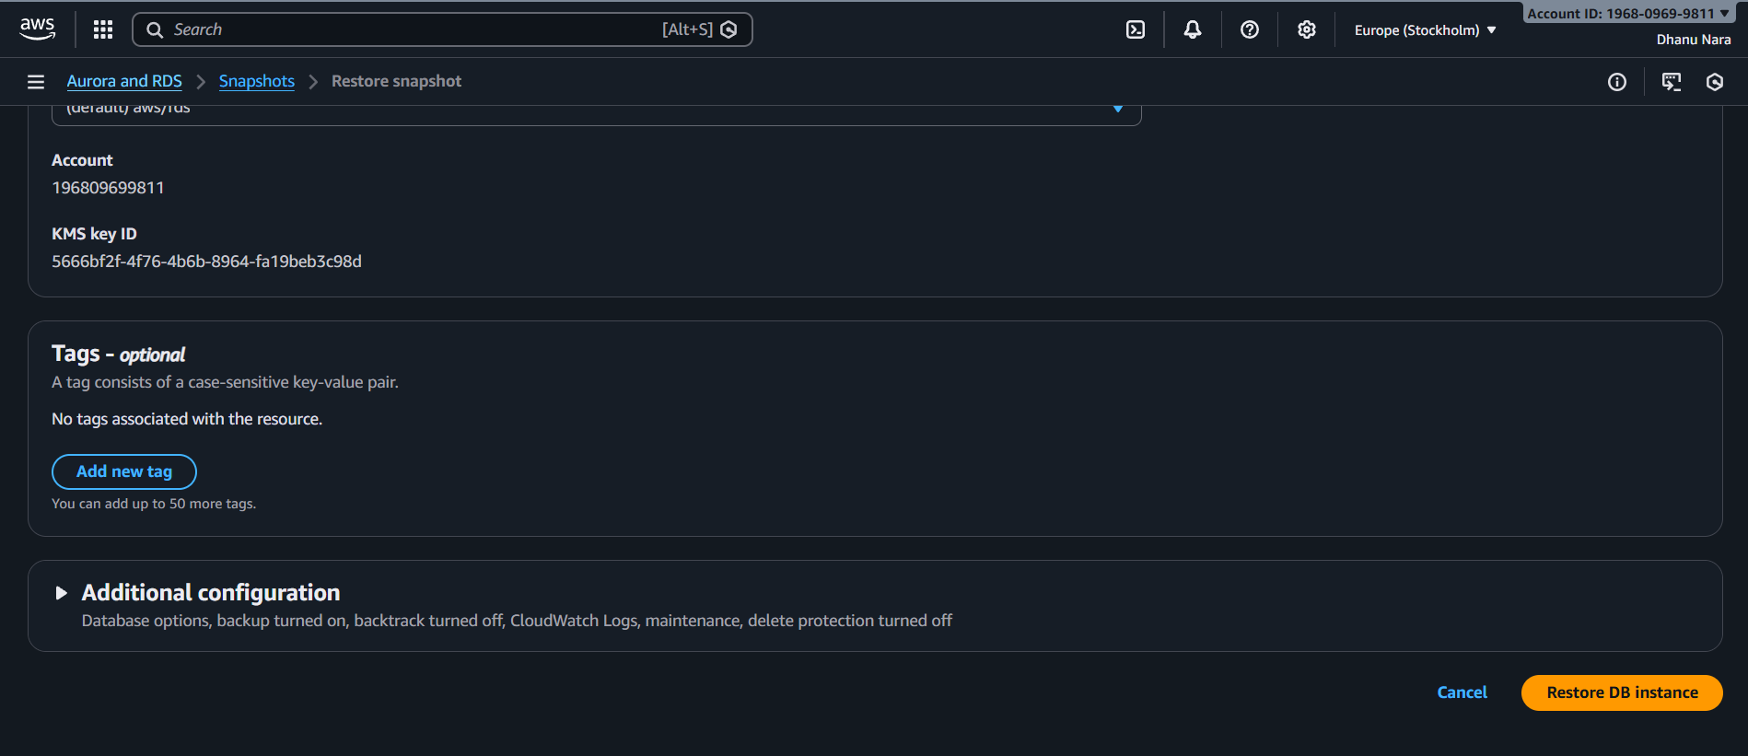
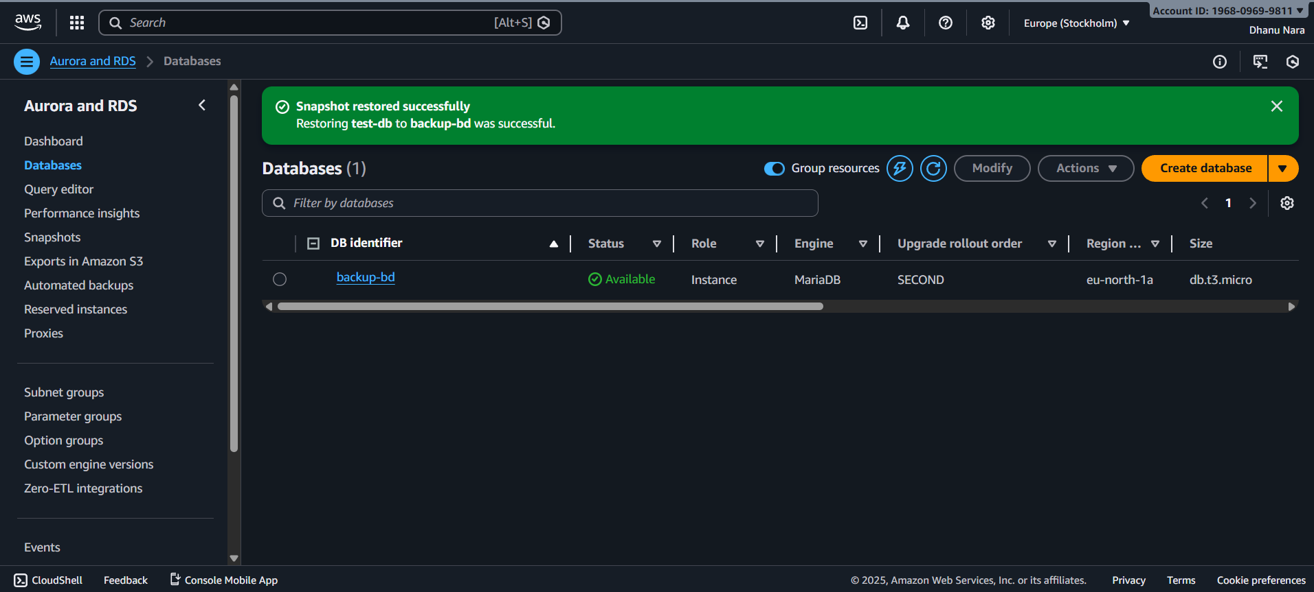
Now new endpoint will form login with that and go the database and search data using select * from table1;
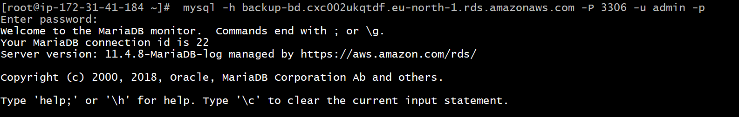
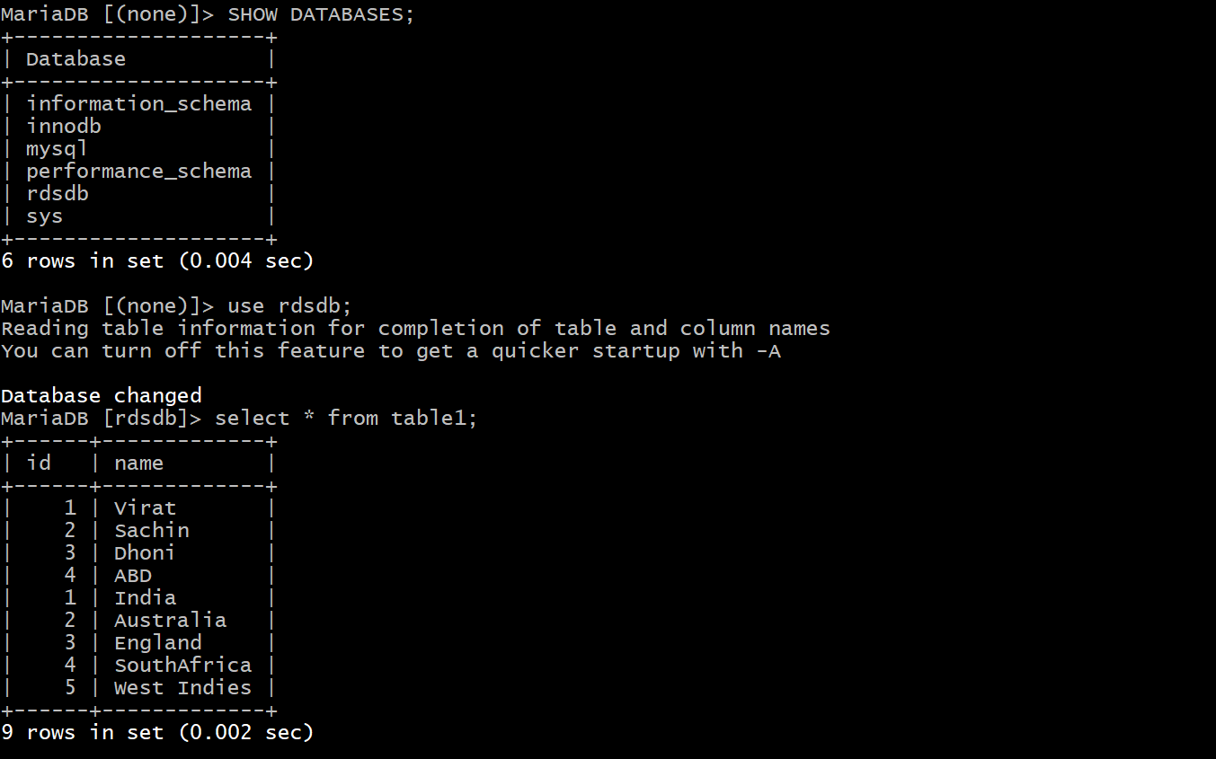

CONCLUSION:
Database backup was successfully taken using mysqldump and restored into a new DB using MySQL import commands, enabling safe recovery or migration of data.

10.Creata read replica.

TITLE:
Read replica

OBJECTIVE:
To create a read replica of the existing RDS database for read-only queries and load distribution.

PREREQUISITES:
Database

STEP-BY-STEP-IMPLIMENTATION:
Select the database to create read replica and click on actions and click on create read replica.
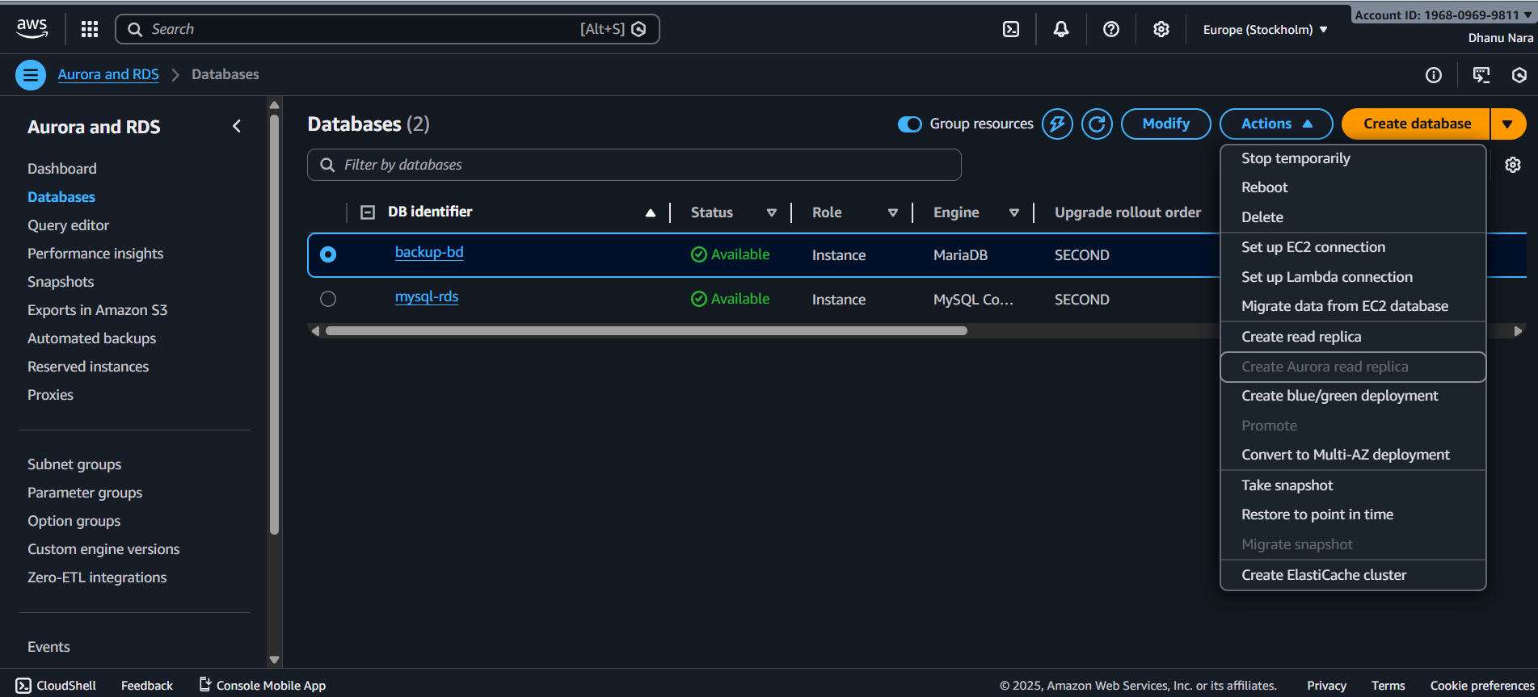
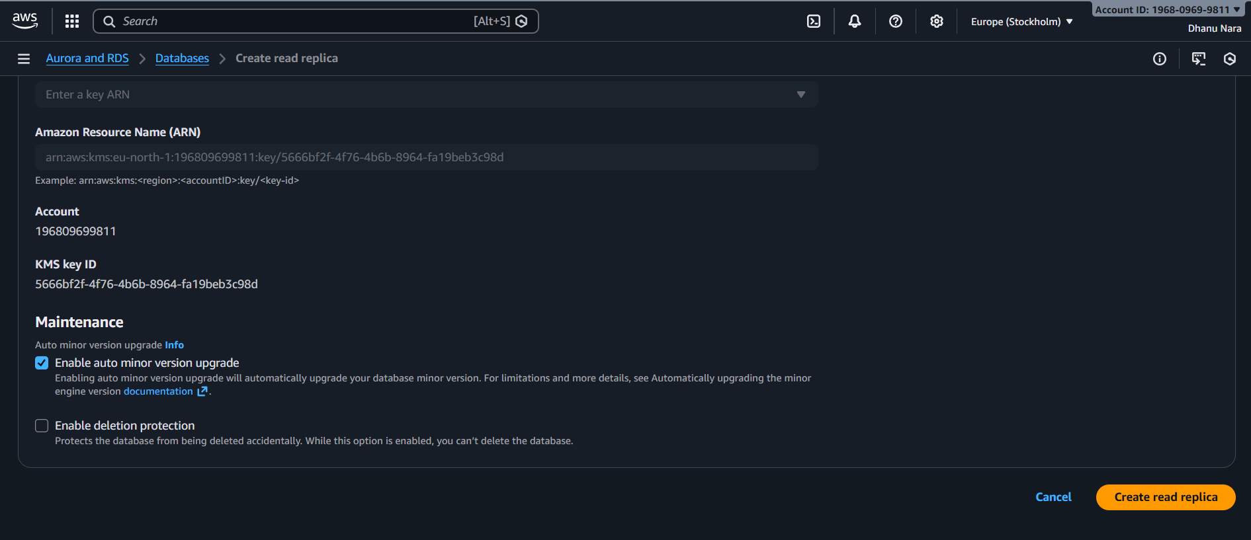

CONCLUSION:
A read replica was successfully created from the primary RDS instance using GUI, useful for offloading read-heavy queries, improving performance, and enabling disaster recovery or future promotion to standalone DB.

